

Course Code : CSE 404

Course Title : Software Engineering and ISD Laboratory

Project name : Bus ticket booking management system

Experiment no: 11

Experiment name: Application of Gantt chart and PERT for your Project scheduling

**Submitted To**

**Dr. Mohammad Zahidur Rahman**

Professor

**Dr. Md. Humayun Kabir**

Professor

Department of Computer Science & Engineering Jahangirnagar University, Savar.

Group No : 02

Group members :

|  |  |  |
| --- | --- | --- |
| **Sl** | Class Roll | Name |
| 01 | 342 | Tama Shil |
| 02 | 370 | Prokash Maitra |
| 03 | 374 | Mubasher adnan jihad |
| 04 | 375 | Pritam Saha |

**Prokash Maitra**

**Roll:370**

**Grant chart for online bus ticket management system:**

Creating a Gantt chart for the online bus ticket management system project can help you visualize the timeline and dependencies of the various tasks and activities involved. Below is a simplified Gantt chart for this project:

Project Timeline:

The project is estimated to span several months, with specific tasks and durations as follows:

1. Project Initiation (5 days): This phase involves defining the project's scope, objectives, and initial requirements.
2. Requirements Gathering (10 days): Detailed functional and non-functional requirements will be collected to guide system development.
3. System Design (15 days): The architecture, database schema, and user interfaces will be designed during this phase.
4. Development (40 days): The actual development of the online bus ticket management system, including both frontend and backend components.
5. Security Implementation (10 days): Security measures, such as encryption and authentication, will be implemented to protect user data.
6. Payment Integration (15 days): Integration with payment gateways like PayPal and credit card processing will be completed.
7. Testing (20 days): Rigorous testing, including unit, integration, and user acceptance testing, will be conducted to identify and resolve any issues.
8. User Registration and Authentication (10 days): This phase involves implementing user registration, login functionality, and password recovery.
9. Reporting and Analytics (15 days): Tools for analyzing booking trends and revenue will be developed.
10. Documentation (10 days): Comprehensive user manuals and technical documentation will be prepared.

**Tama Shil**

**ID:342**

1. Quality Assurance (25 days ): Ongoing quality assurance efforts, including code reviews and testing, will ensure system quality.
2. Deployment (5 days): The system will be deployed to a production server, and the production environment will be configured.
3. Training (ongoing): Staff and users will receive training on how to use the system effectively.
4. Marketing and Promotion (ongoing): Strategies will be developed to attract users to the platform.
5. Maintenance and Support (ongoing): Continuous system maintenance and technical support will be provided to ensure smooth operations.

Critical Path:

The critical path for this project includes tasks such as Requirements Gathering, System Design, Development, Testing, Quality Assurance, and Deployment. Any delays in these critical tasks will directly impact the project's completion date.

The grant chart for online project management system is given below:

**Pritam Saha**

**ID:375**

**Pert chart**

A PERT chart is a diagram of a project’s timeline and milestones. It visually maps out an entire project so you can easily see milestones, timelines, and who is responsible for what. PERT stands for Program Evaluation and Review Technique.

Creating a PERT (Program Evaluation and Review Technique) chart for an online bus ticket management system project involves defining the project's tasks, their dependencies, and the estimated durations. Here's a simplified PERT chart for this project:

1. Project Initiation

- Duration: 5 days

1. Requirements Gathering

- Duration: 10 days

- Dependency: Project Initiation

1. System Design

-Duration: 15 days

-Dependency: Requirements Gathering

1. Development

- Duration: 40 days

- Dependency: System Design

1. Security Implementation

- Duration: 10 days

- Dependency: Development

1. Payment Integration

- Duration: 15 days

- Dependency: Security Implementation, Development

1. Testing

- Duration: 20 days

- Dependency: Development

1. User Registration and Authentication

- Duration: 10 days

- Dependency: Payment Integration, Security Implementation

1. Reporting and Analytics

- Duration: 15 days

- Dependency: Development

1. Documentation

- Duration: 10 days

1. Quality Assurance

- Duration: 25 days

- Dependency: Development, Testing

**Mubasher Adnan Jihad**

**Roll:374**

1. Deployment

- Duration: 5 days

- Dependency: Quality Assurance, Security Implementation

1. Marketing and Promotion

- Duration: Ongoing

1. Maintenance and Support

- Duration: Ongoing

In this PERT chart:

* Each task is represented as a node.
* Arrows indicate task dependencies, with the arrow direction showing the flow from predecessor to successor tasks.

The PERT chart for online bus ticket management system- 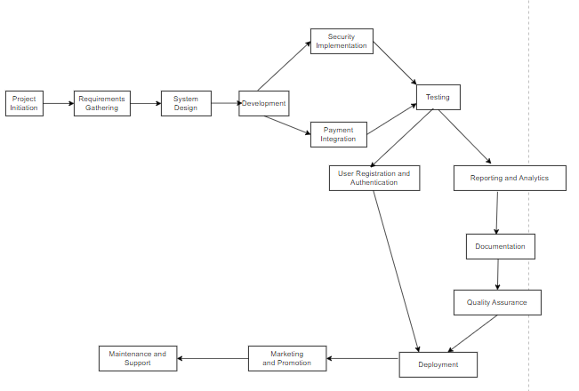



Course Code : CSE 404

Course Title : Software Engineering and ISD Laboratory

Project name : Bus ticket booking management system

Experiment no: 11

Experiment name: Application of Gantt chart and PERT for your Project scheduling

**Submitted To**

**Dr. Mohammad Zahidur Rahman**

Professor

**Dr. Md. Humayun Kabir**

Professor

Department of Computer Science & Engineering Jahangirnagar University, Savar.

Group No : 02

Group members :

|  |  |  |
| --- | --- | --- |
| **Sl** | Class Roll | Name |
| 01 | 342 | Tama Shil |
| 02 | 370 | Prokash Maitra |
| 03 | 374 | Mubasher adnan jihad |
| 04 | 375 | Pritam Saha |